Using Thermal Analysis to Evaluate Plasticizer Content in Plastic Medical Devices

Plasticizers are a critical component in many plastic devices, and particularly so in many medical devices. Quantifying their presence and knowing their rate of evaporation from a product over time can be key pieces of information to ensure product quality. Teel Analytical Lab (TAL) has significant experience using thermal analysis methods, both differential scanning calorimetry (DSC) and thermogravimetric analysis (TGA), to examine plasticizer content and properties in a variety of medical products. The tests detailed below demonstrate the range of questions that can be answered with thermal analysis and showcase TAL’s ability to apply it for advanced testing needs.
Definitions
DSC measures the difference in the amount of energy required to increase the temperature of a sample in comparison to a reference. DSC is especially useful for determining the temperature at which a material transitions to different states, including glass transition, melting, and crystallization. A DSC instrument tracks changes in the material at different temperatures along a curve, information which can be used for quality control and research and development.
TGA is a thermal analysis method used to measure changes in a material’s mass as it experiences changes in temperature over time. TGA is useful in determining the thermal stability of polymers, whether the polymer contains any volatile ingredients, and in providing information on how much heat the material can handle before it begins to degrade.
Identifying Plasticizer Content in CABs Using Glass Transition Temperature
For one test, Teel utilized DSC thermal testing to examine extruded cellulose acetate butyrate (CAB) products and quantify their plasticizer content. The examined products are used as protective layers over glass vials to prevent injury when the vials are broken.
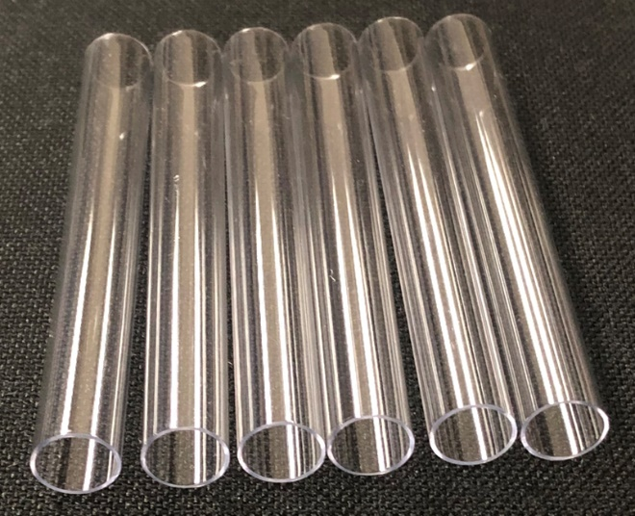
The vial covers are manufactured in two different CAB materials, and TAL was tasked with examing multiple boxes of them to determine which of the two materials and how many of each were in a particular lot. Since the vial covers contained different, previously known levels of plasticizer (10% and 13%), TAL sought to identify the different parts by plasticizer content.
Because no other tool available was sensitive enough to detect such a small difference in plasticizer, TAL decided to analyze the parts using DSC to determine their different glass transition onset temperatures (where a material transitions from solid to formable). The amount of plasticizer in a material has a measurable impact on glass transition (decreasing as plasticizer content increases).
Medical vial protector samples
TAL started by using DSC to initially characterize the different CAB resins with different levels of plasticizer from customer provided samples. With that step completed, TAL could run DSC on the parts and examine the differences in glass transition from the virgin materials. TAL then analyzed a part known to have been made with the 10% plasticizer material as a reference.
Now ready to begin identifying the parts in question, TAL pulled and tested parts from one box in the middle of the lot, one from the end of the lot, and several boxes in between, comparing them for glass transition temperatures. The results obtained are shown in the table and DSC chart below.

Sample Name | Glass Transition Onset (°C)
Reference Part | 107.18
Middle (Box 24) | 107.28
End (Box 45) | 100.64
10% Plasticizer Content | 105.99
13% Plasticizer Content | 102.09
Box 26 | 105.62
Box 28 | 105.29
Box 30 | 105.93
Box 35 | 103.88
Box 40 | 102.74

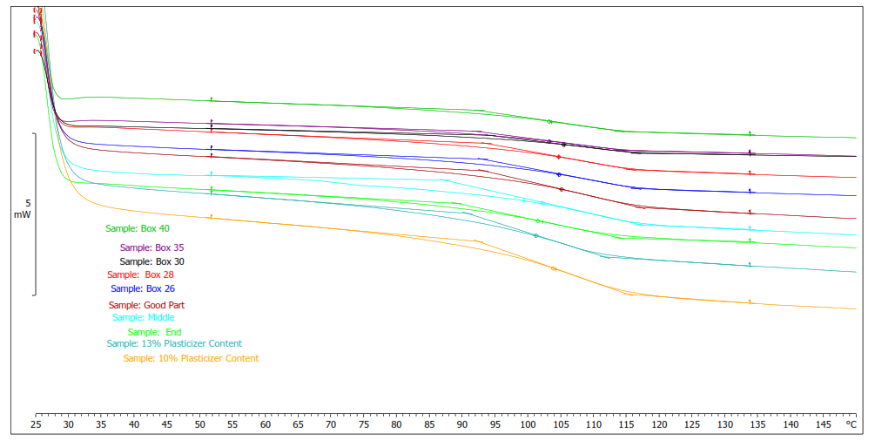
DSC analysis results for medical vial samples

Based on the results, it appeared that the middle box (box 24) may not have had any of the 13% plasticizer content present. The end box appeared to have been fully composed of the 13% plasticizer content, while boxes 26-30 appeared to be composed mostly of the 10% plasticizer resin, but may also have had some 13% plasticizer resin present.
TAL’s work with DSC allowed corrective action to be taken to ensure the correct parts would be used in the customer’s end product. Little else besides DSC would have allowed such a finely detailed analysis.
Kinetic Study of Plasticizer in CABs
For another testing project, TAL used both TGA and DSC to examine the plasticizer content of a CAB resin used in manufacturing a different medical device. The customer wanted to know the rate at which the CAB material, which contained 13% plasticizer content, would lose plasticizer to evaporation in order to understand the product’s functional life. The customer was concerned that the product may crack or become too brittle if it lost plasticizer too quickly, resulting in product failure. The TGA results were used in conjunction with sophisticated kinetic modeling software, which allowed TAL to extrapolate the TGA data and predict the shelf life of the devices out to nearly two years.
TAL first conducted a moisture test (ASTM D7191) on the resin, determining the moisture content to understand its contribution to the weight loss observed in further testing and in the kinetic model. The results showed 0.1339% moisture content.
TAL then conducted a series of TGA tests on material samples at different temperatures (110°C, 140°C, 170°C, and 200°C), each for the duration of a week. A thermogram of the 140°C sample is below.
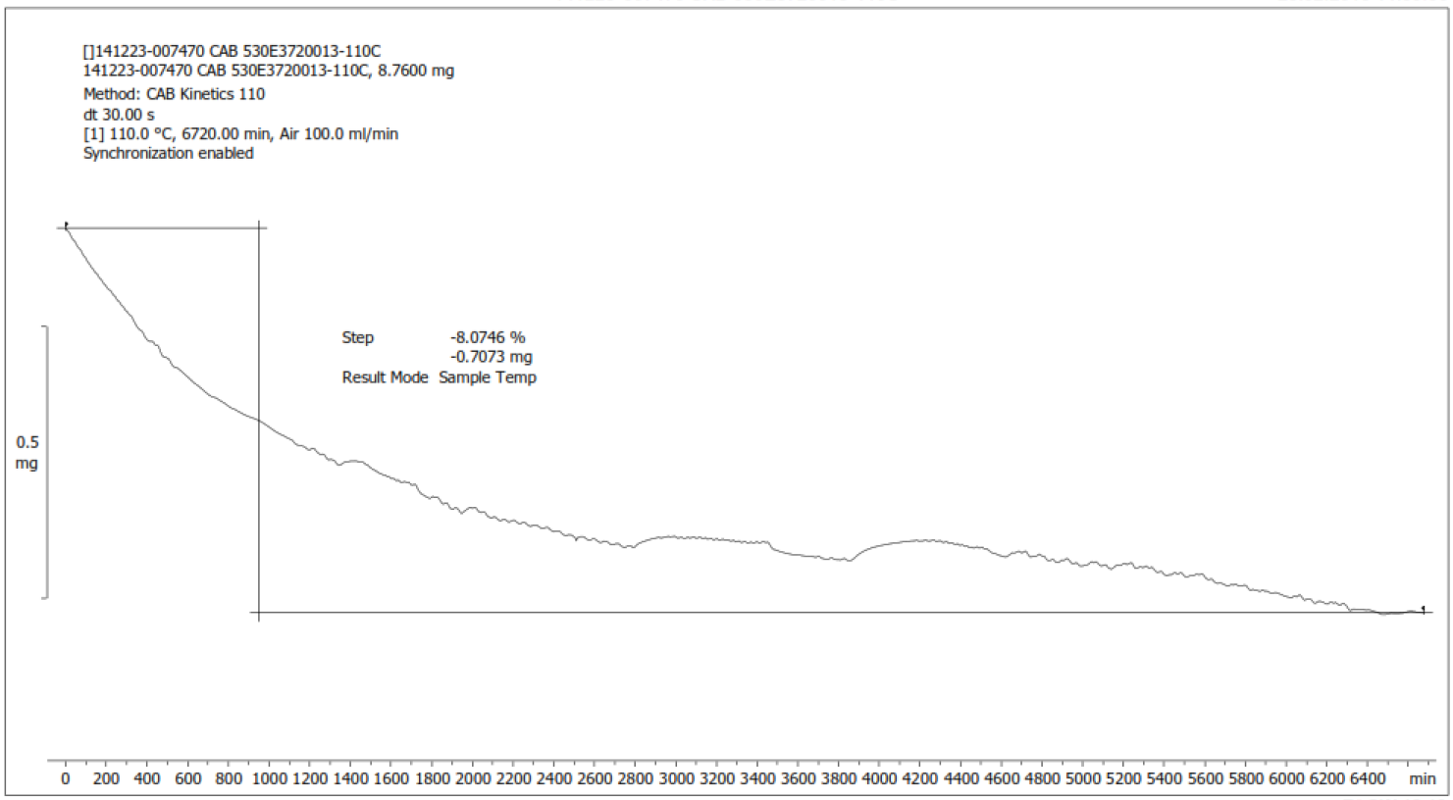
140°C sample thermogram
The results of each test were then entered into the kinetic modeling software and extrapolated out to two years at various temperatures to create a lifetime prediction model (LPM). The kinetic model predicted that all accelerated aging conditions except for 4°C, would experience at least an 8.07% plasticizer loss. Below is the LPM displaying an evaporation level of up to ~8.07%.
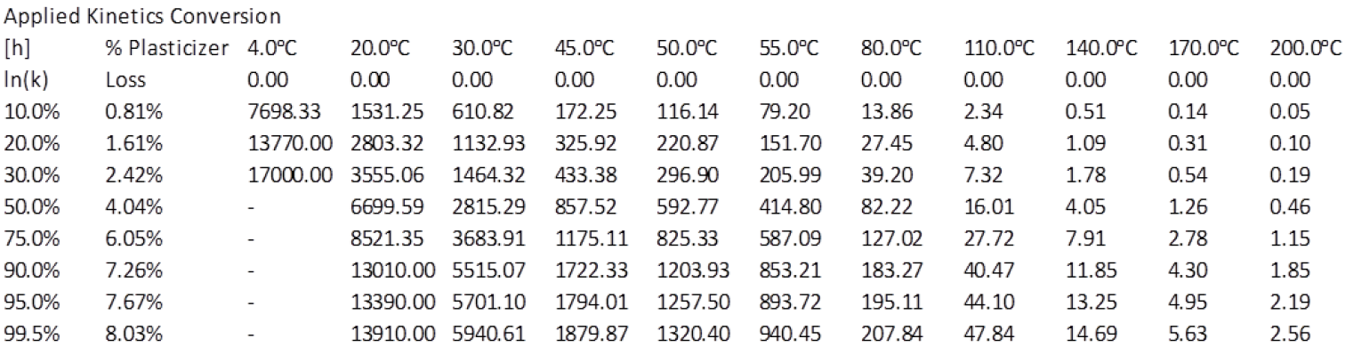
Kinetic Model Results
The percentages in the left column are relative to 8.07%. For example, 50% in the left column is equivalent to ~4.04% plasticizer evaporation.
TAL then tested the accuracy of the model with two more TGA tests, this time with samples at 50°C and 80°C. The 50°C result produced a 2.52% loss over the span of 336 hours, while the 80°C result produced a 1.16% loss over the span of 19.5 hours. Both results fell within the kinetic model at their respective levels, confirming the model’s accuracy.
Although the model was used to predict only plasticizer evaporation, there would be an impact on the overall evaporation due to moisture (the previously established 0.1339% determined in the initial moisture analysis). However, this impact would only be 1.66% of the total weight loss used to create the model.
TAL then conducted DSC analysis to confirm the TGA sample weight loss was from the evaporation of plasticizer and not another element of the samples. DSC results showed the glass transition temperature of the sample resin prior to isothermal testing exposure was 101°C. If the loss was in fact from plasticizer, DSC analysis of the sample kept at 140°C for one week would display a considerably higher glass transition temperature. The sample subjected to 140°C (which produced a weight loss of ~10.51%) in fact showed a shift in the glass transition to 122°C. This indicated plasticizer loss, confirming the weight loss produced during the isothermal analysis was from plasticizer evaporation.
In the end, the kinetic model was a success, helping the customer understand the expected shelf life of their products. The kinetic model was able to reasonably predict the 50°C and 80°C plasticizer evaporation, and plasticizer evaporation was confirmed by the DSC analysis.
Conclusion
The projects above demonstrate the capabilities of thermal analysis in examining plasticizer content in medical products, and TAL’s use of the methods, even in conjunction with modeling software, demonstrate the value of an experienced analytical lab for third-party testing or as an in-house quality resource.

